**Request for Cancellation of 2023 ICDM Registration**

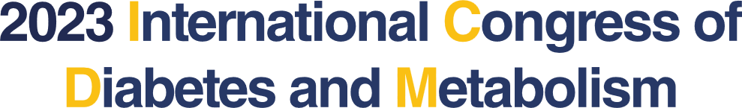

※ Please fill out the form and send it to the congress secretariat at [icdm@diabetes.or.kr.](mailto:icdm@diabetes.or.kr.)

**I. Personal Information**

|  |  |  |  |
| --- | --- | --- | --- |
| **ID** |  | **Membership** | **□ Member □ Non-member** |
| **Name** |  | **Profession** |  |
| **Organization** |  | **Date of Birth** | (i.e. 1980-Nov-16) |
| **Phone** |  | **E-mail** |  |
| **Credit Card No.** |  | **Credit Card Vendor** |  |

**II. Cancellation of Registration**

|  |  |  |  |
| --- | --- | --- | --- |
|  | **Early registration**  **(~15 September 2023)** | | |
| **Domestic** | | **International** |
| **Member** | **Non-Member** |
| **Regular Rate** | [ ]  USD 280 | [ ]  USD 350 | [ ]  USD 280 |
| **Reduced Rate** | [ ]  USD 180 | [ ]  USD 230 | [ ]  USD 180 |
| **Low Income Countries** | [ ]  USD 150 | | |
| **Dinner** | [ ]  USD 30 **Cancellation of the dinner is not possible separately.**  **If you wish to cancel the dinner, please cancel your**  **entire registration and re-submit your payment.** | | |

|  |  |  |  |  |
| --- | --- | --- | --- | --- |
| **NOTE**   * Cancellation of registration is only acceptable in written form BEFORE the deadline of registration.  |  |  | | --- | --- | | **By 15 September 2023** | 100% refund | | **From 16 September 2023** | No refund | |
|  |

*I hereby request the cancellation of 2023 ICDM registration.*

**YYYY/MM/DD Name (Signature)**